**NETWORKING & SYSTEM ADMINISTRATION LAB**

**Name: Nikhil Jais**

**Roll No:25**

**Batch:B**

**Date:30/03/22**

**Experiment No.: 1**

**Aim**

Note on Hardware Components of Computer.

**Procedure**

## **What is Computer Hardware?**

Computer hardware is a hardware part of a computer system.

In simple words, only those parts of the computer system which we can see or touch are called computer hardware.

Hardware is an important part of our computer system without which the computer is incomplete.  
  
You cannot use a computer without hardware and without hardware, there cannot be a computer system or construction.

### **Mouse**

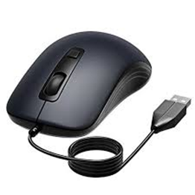

A mouse is a hardware input device that is used to move the cursor or pointer on computer screens.  
  
It can also be used to run computer programs, select items in a graphical user interface, and manipulate objects in the computer world.  
  
Some common examples of how it can be used are clicking on buttons, scrolling up and down the screen, selecting files, opening folders, and so on.

### **2.Keyboard**

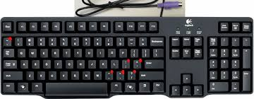

Hardware Components of Computer - Keyboard

A keyboard is an input device that you use to enter data into a computer.  
  
It's also called the input device for your computer. Keyboards are used with PCs, laptops, tablets, and other devices.  
  
There are many different types of keyboards, but the most common one is the QWERTY keyboard.  
  
A QWERTY keyboard has all the letters in alphabetical order on it.  
  
This is different from some other types of keyboards, like Dvorak or Colemak keyboards.  
  
For example, these keyboards have keys arranged differently than what you’re used to seeing on a QWERTY keyboard.  
  
And that means that typing on these keyboards will feel like typing in another language at first! But don’t worry - once you get accustomed to it, it feels natural!

### 

### **3.Monitor**

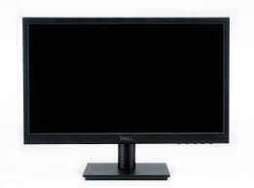

Hardware Components of Computer - Monitor

Personal computers use a monitor to display data, run the software, and interact with the user.  
  
A monitor is an electronic visual display that connects to your computer or laptop.  
  
It is used for displaying images, text, videos, games, web pages, and more.  
  
Monitors are available in different sizes depending on the needs of the person using them.  
  
The most common [types of monitors](https://quicklearncomputer.com/types-of-monitor/) are CRT (cathode ray tube), LCD (liquid crystal display), and LED (light-emitting diode).

### **4. Motherboard**

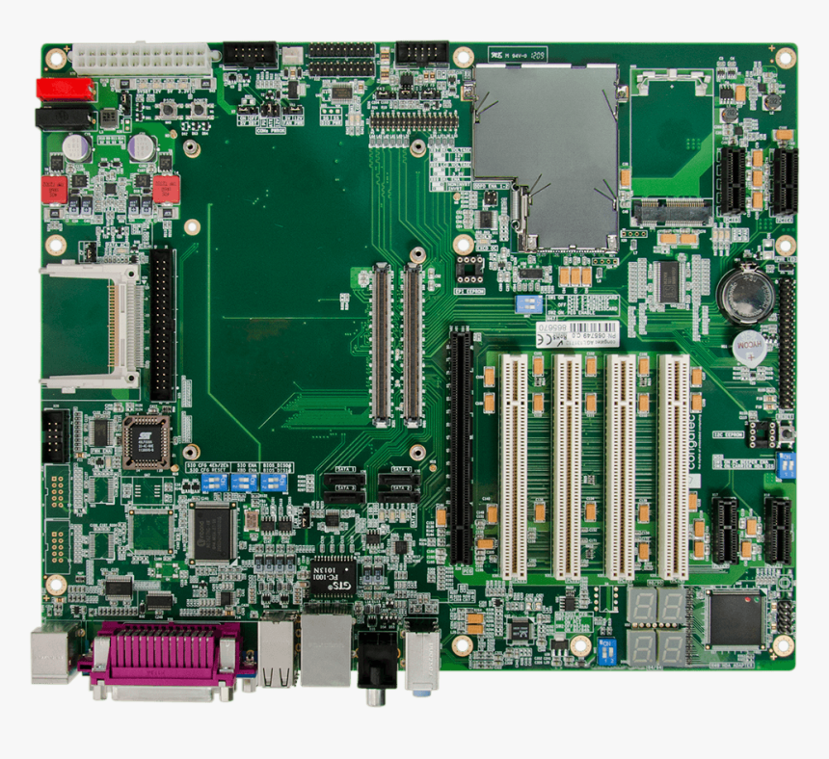

The motherboard is the backbone of our computer system. It's the central processing unit or CPU.  
  
It connects all the other components, like memory and graphics card, to the power supply.  
  
The motherboard is where all the wires are plugged in and it's also where you place your RAM, which is your computer's working memory.  
  
The motherboard is what makes one machine different from another.  
  
Motherboards are made up of tiny transistors that control the flow of electricity through copper tracks on their surface.  
  
These transistors are called Integrated Circuits or ICs for short.

### **5. CPU ( Central Processing Unit )**

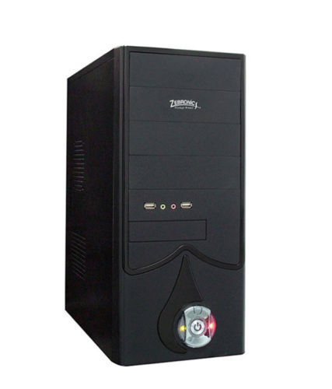

A CPU, or central processing unit, is the brain of a computer. The CPU processes information and runs programs.  
  
It functions as a control unit that executes programs according to instructions in its program memory.  
  
The CPU contains elements such as registers, an arithmetic logic unit (ALU), and control logic for sequencing instructions.

### **6. RAM Memory**

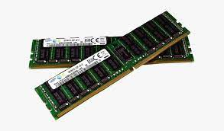

Hardware Components of Computer - RAM Memory

A computer's RAM is a type of computer memory that stores information so the CPU can access it directly.  
  
Computer systems use main memory to store both data and programs.  
  
The more RAM you have, the more data your system can process at one time.  
  
This will lead to more efficient operations on your computer, which translates into better performance for the user.

### **7. ROM Memory**

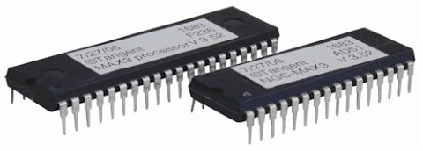

Picture of ROM Memory

ROM stands for a type of memory chip that can be read from but not written to.  
  
In other words, it's a form of data storage that can't be changed after being programmed.  
  
It's sometimes called "non-volatile" memory because the stored information will remain even when not powered up or in use.  
  
ROM is often used to store a computer's basic start-up instructions and certain types of data, such as your car's onboard computer system and a calculator's data tables.

### **8. Hard Disk Drive**

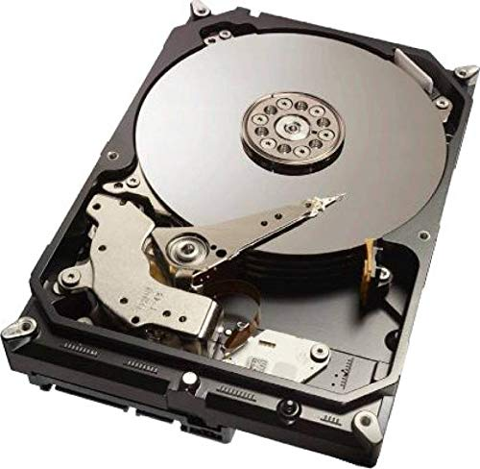

A hard disk drive is a piece of hardware inside a computer that stores information.  
  
It's used to store software and data in a safe place, which can be accessed when needed.  
  
With magnetic storage, there are no moving parts - unlike a CD or DVD player in which you need to move a disk in order to access data.  
  
You can think of it as "a closet" where all your stuff is stored safely.

As long as you have power, you can get to your things when you need them.

### **9. Optical Drive**

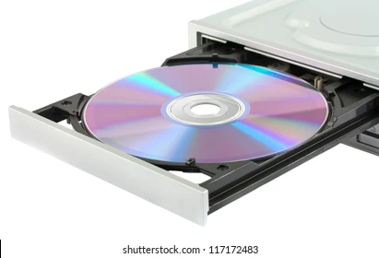

Optical Drives are used in PCs to read and write CDs and DVDs.  
  
The optical drive reads the data from the disc, which can then be transformed into a digital file that is readable by the computer.  
  
This makes it easy to backup files, play music or movies, or copy data from one disc to another.  
  
The term "CD" refers to Compact Discs, which are the most common type of optical drive on modern computers.  
  
They are often used for installing software on your computer, moving data between computers, or writing new programs.

### **10. Power Supply**

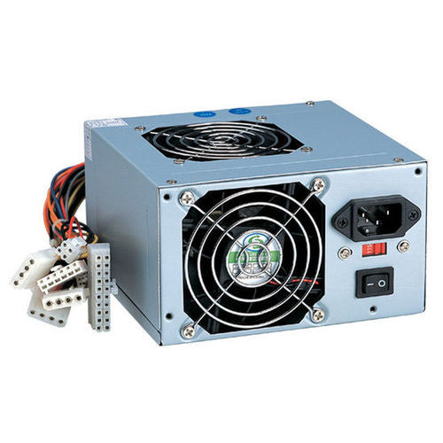

A power supply is an electrical appliance that provides the necessary power to operate a computer.  
  
Computers are powered by electricity, and the power supply converts the alternating current (AC) from the electric outlet into direct current (DC).  
  
The power supply in a computer can be an internal or external component.  
  
It’s important to make sure your power supply is functioning properly.